# 

Game Design Document

By Daniel Foth

Links 1

Overview 1

Objective 1

Character 1

Game Design 1

Game Mechanics 1

Game States 1

Interactions 1

Visual Style 1

Audio Style 1

Level Design 1

Platforms 1

Collectibles 1

Unique Mechanics 1

Gliding 1

Fall Damage 1

Disappearing Platforms 1

Collectibles 1

User Interface 1

Menus 1

HUD 1

User testing 1

Reflection 1

3D Models 1

Character 1

3D Environment 1

Programming 1

Audio 1

Testing 1

Roadmap 1

# Links

GitHub - <https://github.com/DanielsHappyWorks/ObstacleCourse>

OneDrive - <https://studentdkit-my.sharepoint.com/:f:/g/personal/d00165175_student_dkit_ie/EuYeC7woYU5AoA5_RiJEiZ8BoaDmWcpLFk09xcLHbZjkLQ?e=Cmqclh>

Presentation - <https://studentdkit-my.sharepoint.com/:p:/g/personal/d00165175_student_dkit_ie/EYZUqBMZeoFFjaBvmqSQPgsBdPm-1PZuUbX1OMmj-ptTzg?e=cyHAFW>

Demo - <https://studentdkit-my.sharepoint.com/:v:/g/personal/d00165175_student_dkit_ie/EY0Rrr6rQiZEoDrXH1TWQWUBGIMrf443pXA2PWRWHei-6g?nav=eyJyZWZlcnJhbEluZm8iOnsicmVmZXJyYWxBcHAiOiJPbmVEcml2ZUZvckJ1c2luZXNzIiwicmVmZXJyYWxBcHBQbGF0Zm9ybSI6IldlYiIsInJlZmVycmFsTW9kZSI6InZpZXciLCJyZWZlcnJhbFZpZXciOiJNeUZpbGVzTGlua0NvcHkifX0&e=8iy5IW>

Itch.io - <https://boopdood.itch.io/descent>

# Overview

Descent is a game where the player descends a hole. The game's uniqueness comes from a need for the player to manage their descent downwards while minimizing the fall damage. To do so, they have limited use of an umbrella that can be used to float downwards, slowing their descent.

## Objective

The player's goal is to score the highest score they can before they run out of health. The score increases depending on the collectible they collect on each platform.

## Character

The player plays a young girl that has fallen down a hole. Her only choice is to head down in the hopes that this hole has a bottom. On her descent, she must avoid obstacles that send her flying up and down and platforms that vanish under her feet.

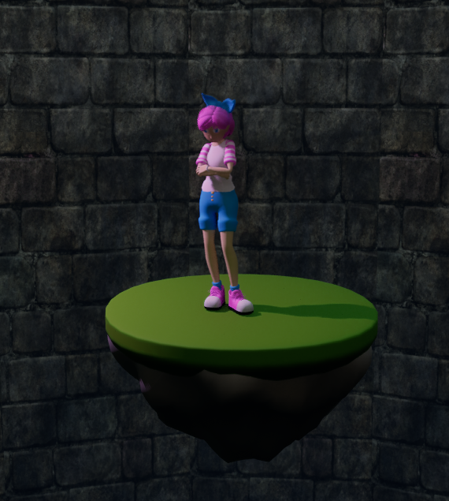

# Game Design

## Game Mechanics

The player jumps from platform to platform. As their falling speed increases, so does the damage they take when they land. They have limited use of the umbrella which slows their fall, allowing them to stay in control of the main character’s descent. The player needs an indication of how much damage they will take. This is conveyed by the distortion of music and will be fully solved by a gradient creeping into the HUD described in a section below.

The player can increase their score by collecting collectibles on each platform. Platforms disappear after their time runs out, which is indicated by a change in the color of the light from the lamp, forcing the player into quick decision making and giving them limited time to recover their umbrella.

## Game States

The game only has a game over state and pause. This shows the player their current and high score. It also gives them the opportunity to quit or try again.

## Interactions

The player can interact with the keyboard or controller.

|  |  |  |
| --- | --- | --- |
| ***Control*** | ***Keyboard & mouse*** | ***Controller*** |
| **movement** | wasd | Right analog |
| **jump** | space | X/A |
| **glide** | space | X/A |
| **camera** | Mouse movement | Left analog |

## Visual Style

The game will have a pastel color pallet with mainly blues and pinks. Darker pinks and reds will signify danger. The hole should look dark and eerie.

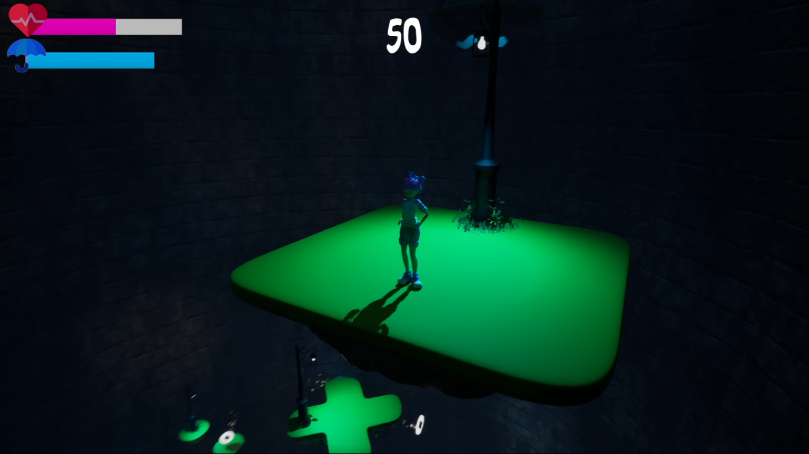

## Audio Style

The game will have jazz music as the main track. This track should be a cozy bop. The track will also become more distorted and pitchy as the player makes their way downward too fast.

Sound effects for running, jumping and landing give the character a feeling of being within the environment.

Collectibles sound like they sparkle, inciting the player to touch them.

# Level Design

## Platforms

The platforms consist of multiple objects. These include:

1. Grass top
2. Rocky Bottom
3. Collectible which the player needs to pick up to increase their score.
4. Lamp which signifies how long the platform has left to exist.

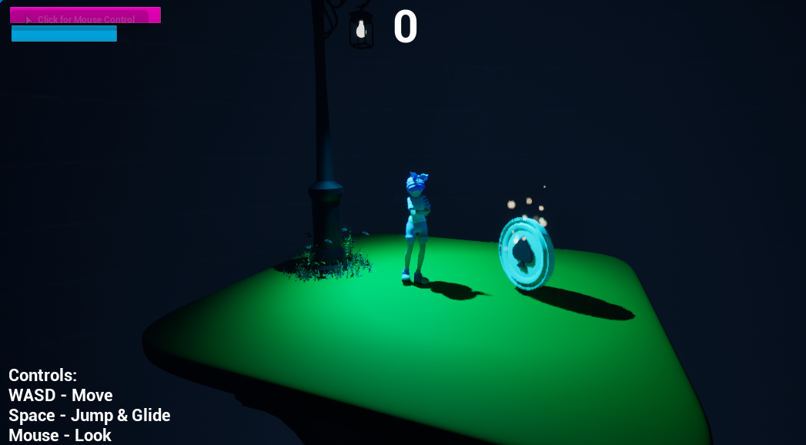

There are multiple platform shapes. Platforms are more complex with more chaotic movements as the player descends. For example, the Donut Platform will force the player through the middle if the player wants the collectible. However, this is a high-risk option. Below is an image of the level with all platforms in use.

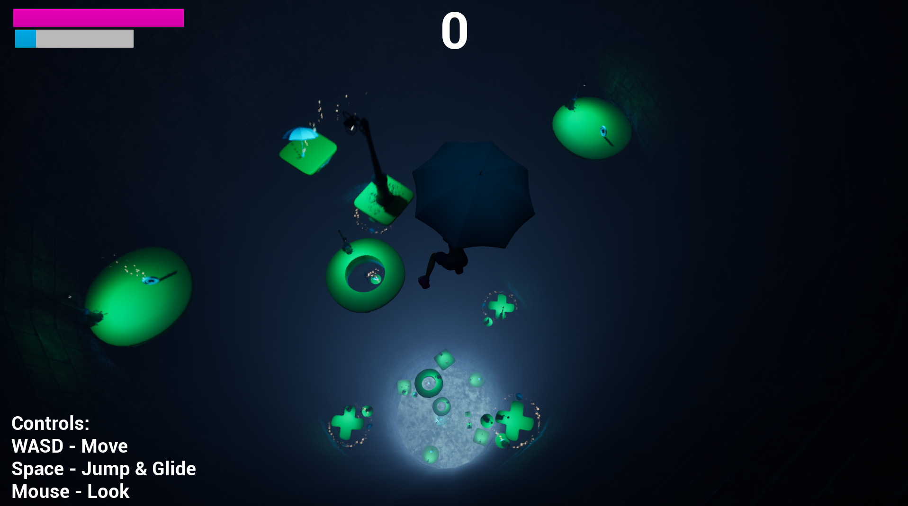

The lamp glows from blue to red while decreasing in intensity. This signifies how much time a platform has left before it disappears. Below is an example of a platform that will soon disappear.

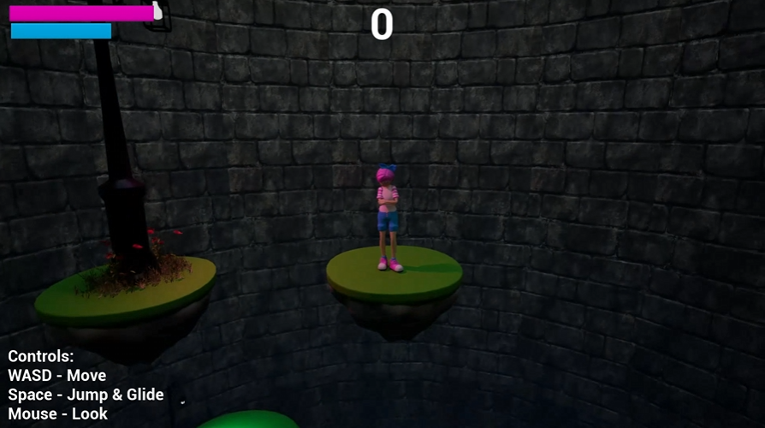

## Collectibles

There are multiple collectibles. Each collectible adds to the player’s score, with some adding more than others. Below is an example of a sparkling collectible with Niagara particle effect system in use.

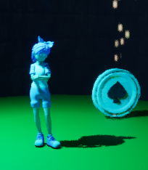

# Unique Mechanics

## Gliding

The player can press the action key (space/X) to glide midair. This slows the player down over time by applying an upward force on the player, minimizing the amount of fall damage they take. When the player is not gliding, they will accelerate downwards until they reach a terminal velocity.

## Fall Damage

The player takes fall damage based on how fast they land on a platform. Hitting the platform at terminal velocity is an instant game over. This uses built-in acceleration due to gravity on the player character.

## Disappearing Platforms

As the player heads downwards, the platforms will disappear to force the player to move downwards. This enforces a sense of urgency. This also means they will lose points if they don't head down quickly enough. This is done by setting a list of platforms that need to disappear before the current platform disappears. The Time to Live will start counting down once the previous platforms are destroyed. As the Time to Live diminishes, the color and intensity of the lamp changes to signify the platform will be gone soon.

## Collectibles

The player collides with a trigger volume that increases the score based on the score defined by the collectible. Each collectible type gives a different number of points.

# User Interface

## Menus

The menus will have a similar color aesthetic to the game, using the same skybox and colors for different UI elements. The main character is going to be present on the menu, gliding downwards.

***Main Menu***

From the main menu, the player can do the following:

1. Play – starts the game, when this is pressed an animation of the character falling off the screen plays, implying they are gliding into the level.
2. Controls – displays the controls to the player
3. Options – allows the player to change and graphics settings
4. Exit – quits the game

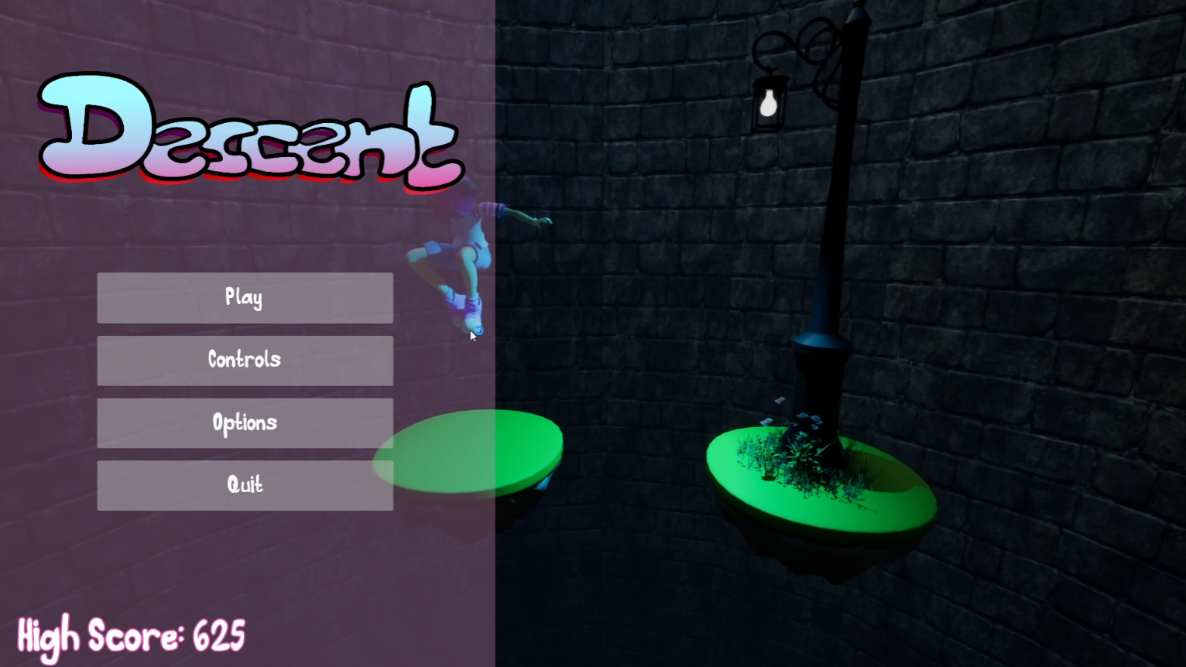

***Options***

This menu includes Graphics options. The player can go back to the menu.

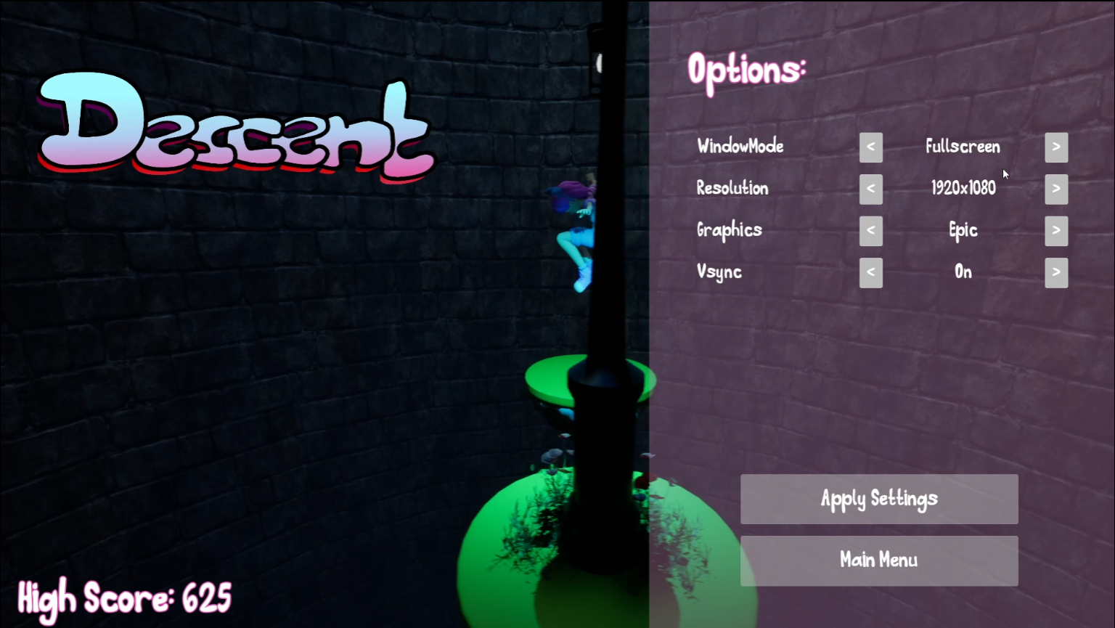

***Controls***

This menu displays the keyboard and controller inputs.

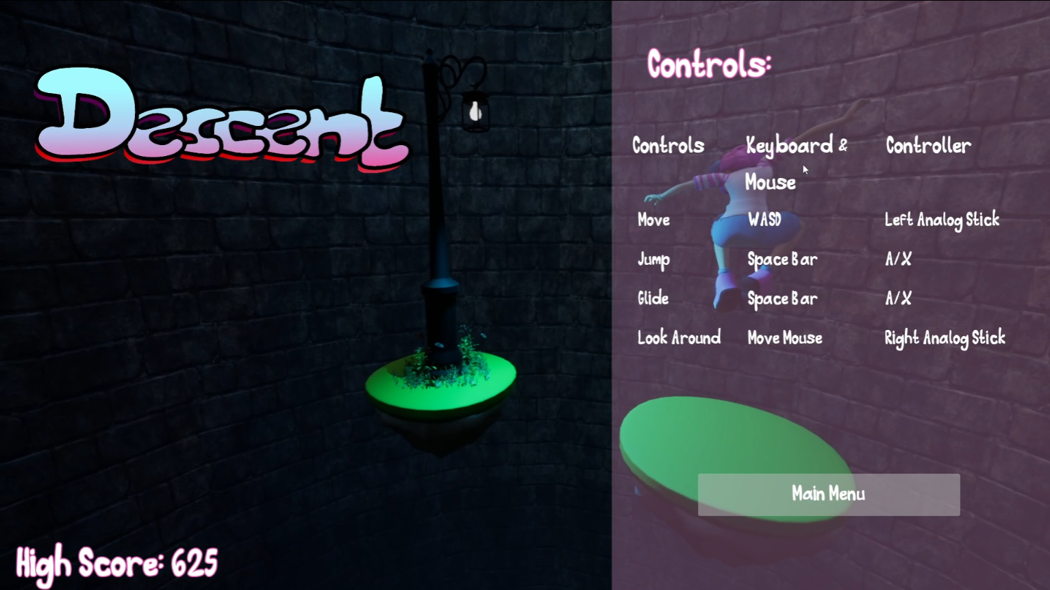

***Game Over Menu***

When the player runs out of health, their current score and existing high score will be displayed on the screen as part of the Beta work. Currently the players can start over or quit from this menu.

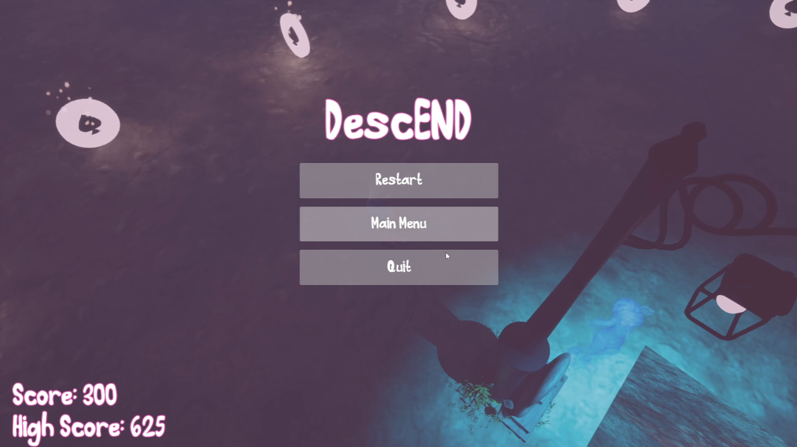

## HUD

The HUD consist of multiple elements, these include:

* Player health bar - shows the player the amount of health until the game ends.
* Umbrella durability - signifies how much time the player can glide for.
* Border - creeps in as the player descends at too high a speed, indicating fall damage.
* Players Score - shows the player how well they are doing.

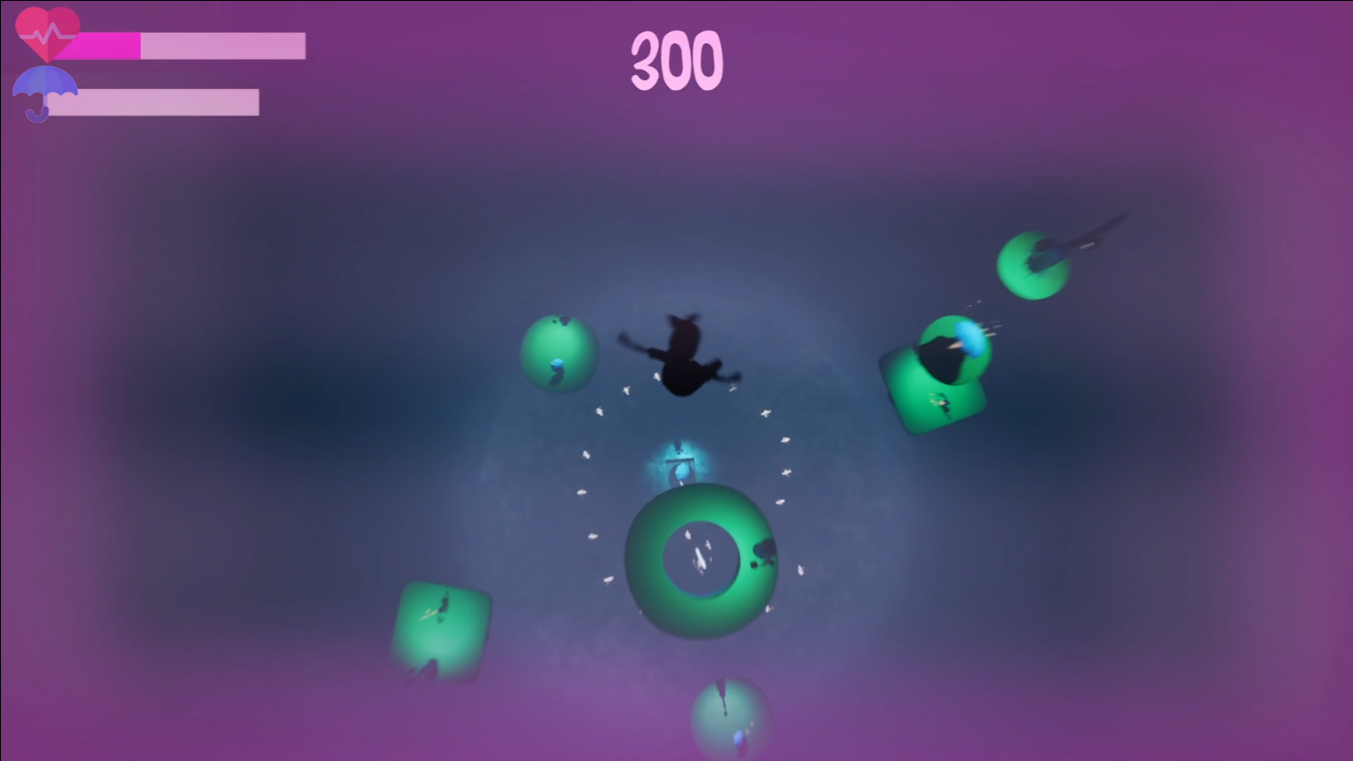

# User testing

The top score from the beta test was 2125. This is impressive as I only scored 1650 myself.

|  |  |  |
| --- | --- | --- |
| Gray Box (8 Responses) | Alpha (8 Responses) | Beta (11 Responses) |
|  |  | Forms response chart. Question title:  What do you think of the demo?. Number of responses: 11 responses. |
|  |  | Forms response chart. Question title:  How do you find the controls?. Number of responses: 11 responses. |
|  |  |  |
|  |  | Forms response chart. Question title:  What do you think of the visuals?. Number of responses: 11 responses. |

Positive trend in all areas, a lot of users shifted their scores up. The beta testers also had some new respondents. Two testers stand out due to a lower score than the alpha. One tester scored the demo poorly due to performance issues on older hardware which is something to investigate. The other didn’t like the way the game started and how the umbrella handling felt.

|  |  |
| --- | --- |
| Improvement Over Gray Box | Improvement Over Alpha |
|  | Forms response chart. Question title: If you have played a previous releases, do you think this one has changed for the better or worse? . Number of responses: 9 responses. |

From the alpha to the beta, we see a lesser improvement than from the gray box to the alpha. This is expected as under the hood less has changed. It was mostly menu work, rebranding and polishing work.

Overall, with the changes the goal of the game comes across better, which is nice as this was a big problem in the last two tests. How the game should be played, and difficulty levels are still up for further discussion.

Things users enjoyed:

* Music/Audio
* Intuitive controls
* Visuals & Atmosphere

Future work from beta testing:

* Powerups – Specifically health boost for balancing purposes as the game is hard
* Performance Enhancements - Game is poorly optimized on lower spec hardware (even with lower graphics options)
* Option menu has a bug – defaults seem to break when applied
* Controller controls are broken in the game and don’t work at all in menus.
* Lighting is broken on lower graphics settings
* Pause menu – needed for players that need to step away from the game

Lecturer feedback

* TODO

# Reflection

## 3D Models

All the 3d models were created in blender, exported to fbx files and imported into UE5.

### Character

**Modelling**

The technique shown in class was used to create the base shape of the character. This was then adjusted to fit the character's body from the reference. There were a few points where the character mesh behaved weirdly, but I fixed it with some time and vertex editing.

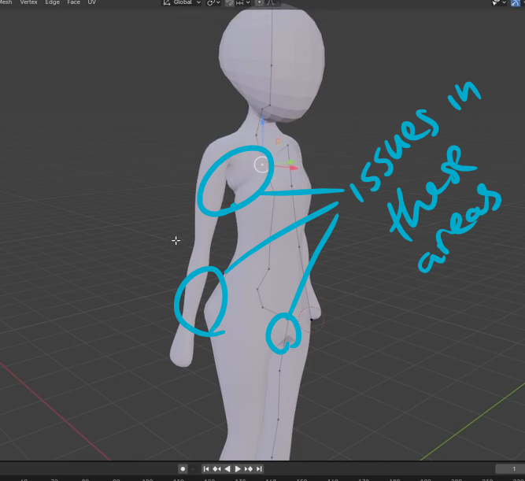

The characters clothes were made by duplicating the body, adding a skin modifier and adjusting the edge loops.

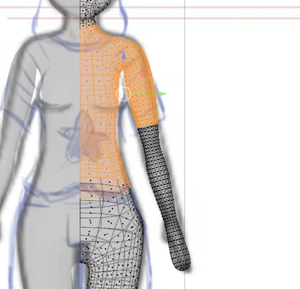

All other parts like shoes, ribbon, hands and hair used the standard box modelling approach with subdivisions. The hands were probably one of the most complicated ones due to the shape and need to attach to the character model.

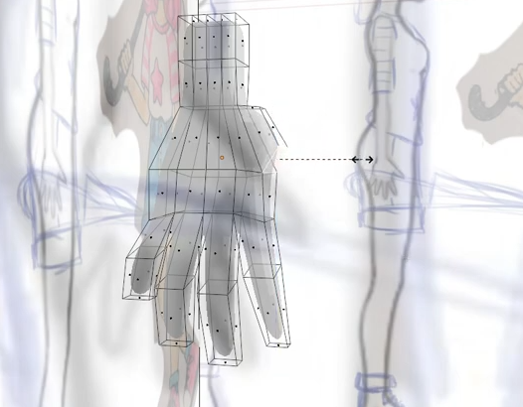

**Texturing**

The texturing consisted of using materials in blender and coloring in areas by selecting quads and assigning colors. This fits with the cartoony look much better than making textures would have.

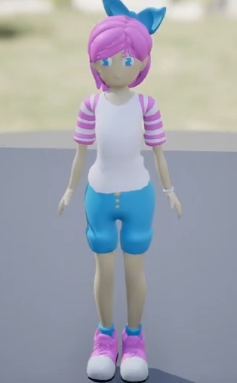

I added a second instance of my character as a ghost at the bottom of the level using Unreal Engine 5 materials. It looks cool and transparent but when changing the texture on the model I needed to assign it to over 30 material entries on the model. Every strand of hair was its own material making this change more painful than needed. Next time I need to make sure I'm correctly assigning materials in blender, so I don't end up with an import as shown in the image below.

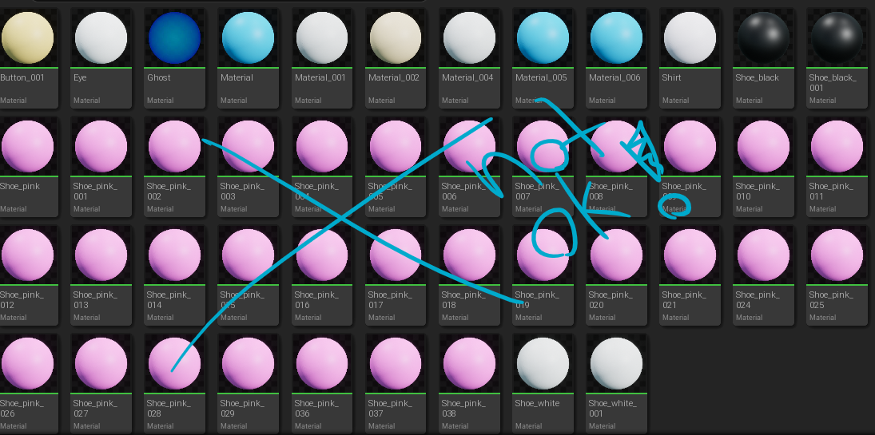

The final ghost effect turned out great though.

**Animations**

All animations were downloaded from Mixamo. A lot of effort was put into making sure the character's persona was conveyed through the way she moves. For example, the idle animation is one that shows the character impatience.

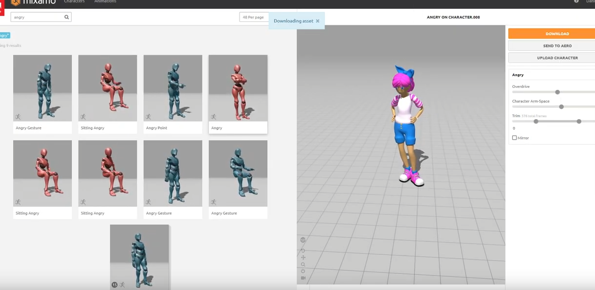

Within UE5 a state machine was used to move between different animations. In the character controller, all states are set based on player input and game state and then used to produce the correct animation.

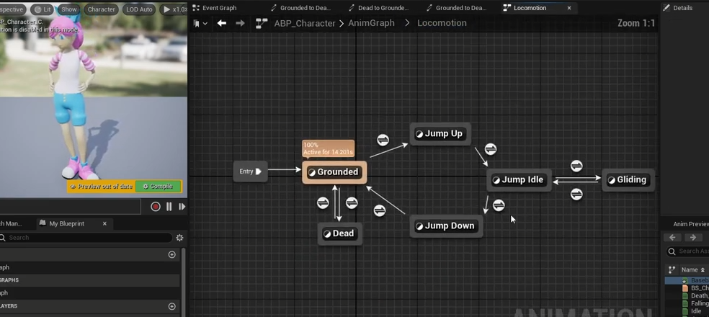

I came across IG_RIGs in UE5 which are the alternative method of doing animations for characters, but it seemed more complicated than following what was shown in class. With UE5.4, this will be easier and Mixamo will be supported by default. This is something to investigate soon.

### 3D Environment

All the environmental models used standard techniques from the previous CAs. Some unique approaches were taken for more complex models. These included:

Using curves to model the lamp

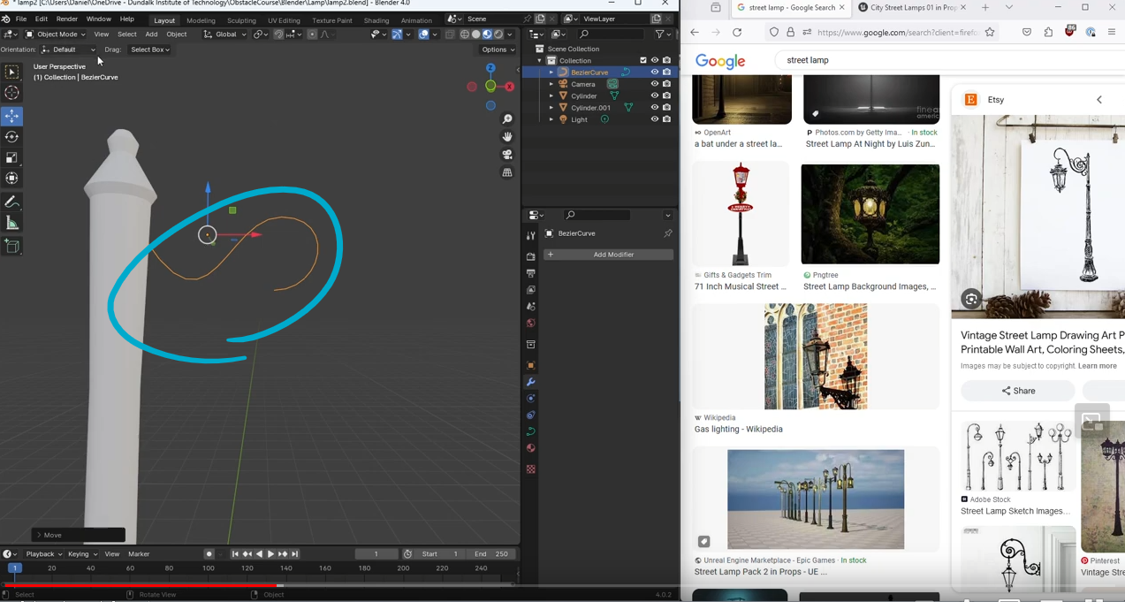

Using multiple points and a skin modifier for the umbrella supports

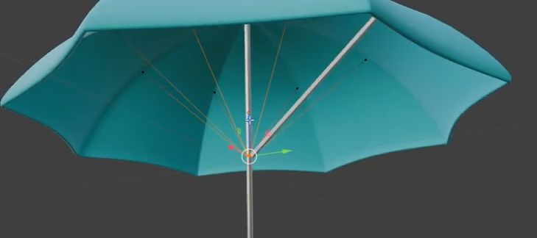

Using a displacement modifier with a noise texture to create the rock under the platform

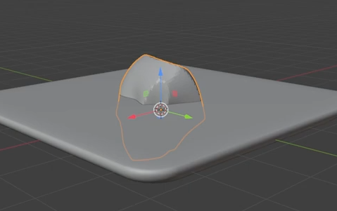

## Programming

All the code and assets are uploaded to GitHub. Files are small enough that they don't require LFS. Some issues were encountered when build files were committed but dropping the local commit and adding correct exclusions to the .gitignore files resolved any issues.

The code itself is a mix of both C++ and blueprints. Blueprints were initially used for placing models within the scene as they are more user friendly, while C++ was used to add more functionality to the platforms and characters. This caused some interesting issues where communication between child actors defined blueprints with C++ seemed impossible, so I opted to expose functions for the blueprints to trigger the C++ code. This was very hacky but it's what makes the lamps work. My code runs on Faith, Trust and Pixie Dust as conventions went out the window in favor of making features work.

## Audio

All the Audio assets were sourced online, which made the addition of audio faster than expected. They were implemented using Sound Cues. For the characters, the sound cues are added to animation timelines.

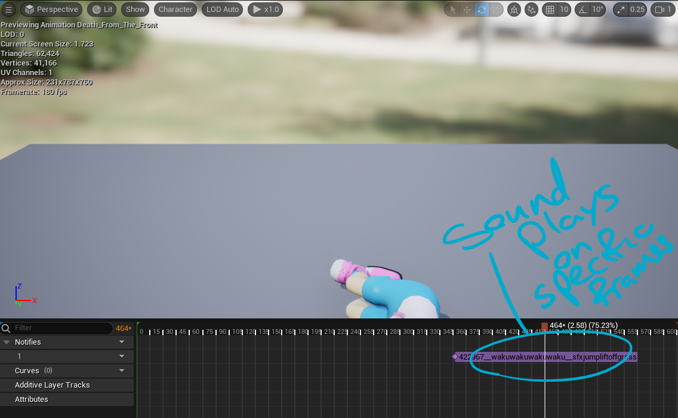

Other sounds were either triggered in C++ or blueprints depending on the object they were associated with. For example, since the collectibles were spawned by C++ code, the sound was done the same way but since the music was an entity in the scene, it was altered and triggered using blueprints.

## Testing

The testing in this phase was done early enough to fix more issues but the testers were busy and most of them didn't have time until the weekend before the delivery. I’m delighted with the results but there are still some glaring issues with the prototype that i need to reflect on and learn from.

## Roadmap

Obstacles and Powerups have been cut. Instead of more gameplay features, the beta phase focused on polishing what already exists while also introducing menus. There was going to be a second wave of polish after the beta test but due to time constraints this was not possible.

